**Dear Parents and Families:**

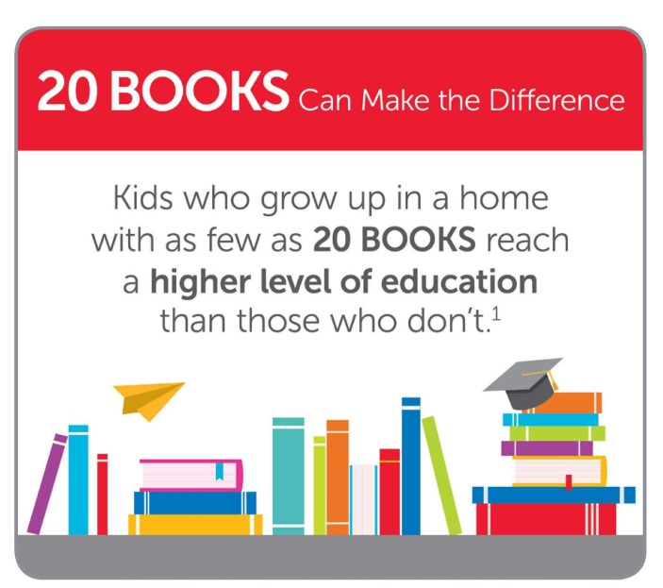

Reading for pleasure inside and outside of school has real and long-lasting benefits. It unlocks the power of information and imagination and helps children discover who they are. It will even help them get into college! Here’s what you can do to help children develop stronger reading skills and a love for reading:

* Set the example. Let children see you read.
* Have a collection of books in the home. Update this collection routinely to keep pace with changing tastes and reading skills. Talk about books and what your child is reading.
* Support our school’s Book Fair. Allow your children to choose their own books to read.

Our Scholastic Book Fair is a reading event that brings the books kids want to read to our school. It’s a wonderful selection of engaging and affordable books for every reading level. Please make plans to visit our Book Fair and be involved in shaping your child’s reading habits.

**Book Fair dates:** [INSERT DATES HERE]

**Shopping hours:** [INSERT TIMES HERE]

**Special activities:** [INSERT SPECIAL ACTIVITIES HERE]

Before you visit the Book Fair, be sure to download the Book Fairs app to help you find the right books for your child. For more information, visit **scholastic.com/apps/bookfairs**.

If you are unable to attend in person, we invite you to visit our online Book Fair at scholastic.com/fair. Our online Fair is available from [INSERT DATE] to [INSERT DATE].

We look forward to seeing you and your family at our Book Fair! Remember, all purchases benefit our school.

Sincerely,

[INSERT PRINCIPAL’S NAME HERE]

Principal